Experiment No.: 5
1.Title: Apply array methods and object handling; create a cart total calculator with discount logic in html, js, css.
2. Software/Tools Required: VSC,HTML,CSS
3. Theory:
A shopping cart application is a web-based system that demonstrates the use of HTML, CSS, and JavaScript to create an interactive e-commerce interface. HTML is used to structure the products, search bar, cart, and order summary, while CSS provides a responsive Amazon-inspired layout with a futuristic neon design. JavaScript handles the dynamic functionality using objects and arrays to store product and cart information. Array methods such as map() are used to display products and cart items, find() is used to locate products, filter() is used for searching and removing items, and reduce() is used to calculate the total cart value and item count. The application also implements conditional discount logic, where discounts of 10%, 20%, or 30% are applied based on the total purchase amount. The final payable amount is calculated by subtracting the applicable discount from the total amount, demonstrating practical use of object handling, array methods, conditional statements, and DOM manipulation in JavaScript.

CODE:
Index.html:
<!DOCTYPE html>
<html lang="en">
<head>
<meta charset="UTF-8">
<meta name="viewport" content="width=device-width, initial-scale=1.0">

<title>NeonCart</title>

<link rel="stylesheet" href="style.css">
</head>

<body>

<!-- HEADER -->
<header>

<div class="logo">
<span>NEON</span>CART
</div>

<div class="search-box">
<input
type="text"
id="searchInput"
placeholder="Search products..."
onkeyup="searchProducts()"
>
<button>🔍</button>
</div>

<div class="cart-button" onclick="scrollToCart()">
🛒 CART
<span id="cartCount">0</span>
</div>

</header>

<!-- NAVIGATION -->
<nav>
<span>☰ All</span>
<span>Electronics</span>
<span>Fashion</span>
<span>Books</span>
<span>Home</span>
<span>Deals</span>
</nav>

<!-- HERO -->
<section class="hero">

<div>
<p class="small-title">NEXT GENERATION SHOPPING</p>

<h1>
SHOP <span>SMART.</span><br>
LIVE <span>BRIGHT.</span>
</h1>

<p>
Discover premium products at futuristic prices.
</p>

<button onclick="document.getElementById('products').scrollIntoView()">
EXPLORE PRODUCTS
</button>
</div>

</section>

<!-- PRODUCTS -->
<main>

<h2 class="section-title">
<span>⚡</span> FEATURED PRODUCTS
</h2>

<section id="products" class="products"></section>

<!-- CART -->
<section id="cartSection" class="cart-section">

<h2 class="section-title">
<span>🛒</span> YOUR CART
</h2>

<div id="cartItems">
<p class="empty-cart">
Your cart is empty.
</p>
</div>

<!-- SUMMARY -->
<div class="summary">

<h2>ORDER SUMMARY</h2>

<div class="summary-line">
<span>Total Amount</span>
<strong>₹<span id="totalAmount">0</span></strong>
</div>

<div class="summary-line discount">
<span>Discount</span>
<strong>- ₹<span id="discount">0</span></strong>
</div>

<div class="neon-line"></div>

<div class="summary-line final">
<span>FINAL AMOUNT</span>
<strong>₹<span id="finalAmount">0</span></strong>
</div>

<button class="checkout" onclick="checkout()">
PROCEED TO BUY
</button>

</div>

</section>

</main>

<footer>
NEONCART © 2026
</footer>

<script src="script.js"></script>

</body>
</html>
Script.js:
// =====================================
// PRODUCT OBJECTS
// =====================================

const products = [

{
id: 1,
name: "Neon Wireless Headphones",
category: "Electronics",
price: 1499,
rating: 4.5,
image: "🎧"
},

{
id: 2,
name: "Smart Watch Pro",
category: "Electronics",
price: 2499,
rating: 4.3,
image: "⌚"
},

{
id: 3,
name: "Premium Laptop Backpack",
category: "Fashion",
price: 999,
rating: 4.4,
image: "🎒"
},

{
id: 4,
name: "Running Shoes X",
category: "Fashion",
price: 2999,
rating: 4.6,
image: "👟"
},

{
id: 5,
name: "JavaScript Programming",
category: "Books",
price: 799,
rating: 4.7,
image: "📚"
},

{
id: 6,
name: "Bluetooth Speaker",
category: "Electronics",
price: 1799,
rating: 4.2,
image: "🔊"
},

{
id: 7,
name: "Gaming Keyboard",
category: "Electronics",
price: 1899,
rating: 4.8,
image: "⌨️"
},

{
id: 8,
name: "Gaming Mouse",
category: "Electronics",
price: 1299,
rating: 4.6,
image: "🖱️"
}

];

// =====================================
// CART ARRAY
// =====================================

let cart = [];

// =====================================
// DISPLAY PRODUCTS
// map()
// =====================================

function displayProducts(productList = products) {

const container =
document.getElementById("products");

container.innerHTML = productList.map(product => {

return `

<div class="product-card">

<div class="product-image">
${product.image}
</div>

<h3>
${product.name}
</h3>

<p class="category">
${product.category}
</p>

<p class="rating">
⭐ ${product.rating}
</p>

<p class="price">
₹${product.price}
</p>

<button
class="add-btn"
onclick="addToCart(${product.id})">

ADD TO CART

</button>

</div>

`;

}).join("");
}

// =====================================
// ADD TO CART
// find()
// push()
// =====================================

function addToCart(productId) {

const product =
products.find(
item => item.id === productId
);

const existingItem =
cart.find(
item => item.id === productId
);

if (existingItem) {

existingItem.quantity++;

}

else {

cart.push({

...product,

quantity: 1

});

}

updateCart();

}

// =====================================
// INCREASE QUANTITY
// =====================================

function increaseQuantity(productId) {

const item =
cart.find(
item => item.id === productId
);

if (item) {

item.quantity++;

}

updateCart();

}

// =====================================
// DECREASE QUANTITY
// =====================================

function decreaseQuantity(productId) {

const item =
cart.find(
item => item.id === productId
);

if (item) {

item.quantity--;

if (item.quantity <= 0) {

removeFromCart(productId);

return;
}

}

updateCart();

}

// =====================================
// REMOVE ITEM
// filter()
// =====================================

function removeFromCart(productId) {

cart =
cart.filter(
item => item.id !== productId
);

updateCart();

}

// =====================================
// UPDATE CART
// =====================================

function updateCart() {

const container =
document.getElementById("cartItems");

// EMPTY CART

if (cart.length === 0) {

container.innerHTML = `

<p class="empty-cart">

🛒 Your cart is empty.

</p>

`;

}

else {

container.innerHTML = cart.map(item => {

return `

<div class="cart-item">

<div class="cart-item-image">
${item.image}
</div>

<div class="cart-item-info">

<h3>
${item.name}
</h3>

<p>
₹${item.price} each
</p>

<div class="quantity">

<button
onclick="decreaseQuantity(${item.id})">
−
</button>

<span>
${item.quantity}
</span>

<button
onclick="increaseQuantity(${item.id})">
+
</button>

</div>

<button
class="remove-btn"
onclick="removeFromCart(${item.id})">

Remove

</button>

</div>

<strong>

₹${item.price * item.quantity}

</strong>

</div>

`;

}).join("");

}

// =================================
// TOTAL USING reduce()
// =================================

let total = cart.reduce(

(sum, item) =>

sum + (item.price * item.quantity),

0

);

// =================================
// DISCOUNT LOGIC
// =================================

let discount = 0;

if (total > 3000) {

discount = total * 0.30;

}

else if (total > 2000) {

discount = total * 0.20;

}

else if (total > 1000) {

discount = total * 0.10;

}

else {

discount = 0;

}

// =================================
// FINAL AMOUNT
// =================================

let finalamount =
total - discount;

// =================================
// DISPLAY
// =================================

document.getElementById("totalAmount")
.textContent = total.toFixed(2);

document.getElementById("discount")
.textContent = discount.toFixed(2);

document.getElementById("finalAmount")
.textContent = finalamount.toFixed(2);

// =================================
// CART COUNT
// =================================

const cartCount =
cart.reduce(

(sum, item) =>
sum + item.quantity,

0

);

document.getElementById("cartCount")
.textContent = cartCount;

// =================================
// CONSOLE OUTPUT
// =================================

console.log("Total Amount:", total);

console.log("Discount:", discount);

console.log("Final amount:", finalamount);

}

// =====================================
// SEARCH
// filter()
// =====================================

function searchProducts() {

const searchText =

document.getElementById("searchInput")
.value
.toLowerCase();

const filteredProducts =

products.filter(product =>

product.name
.toLowerCase()
.includes(searchText)

||

product.category
.toLowerCase()
.includes(searchText)

);

displayProducts(filteredProducts);

}

// =====================================
// SCROLL TO CART
// =====================================

function scrollToCart() {

document
.getElementById("cartSection")
.scrollIntoView({

behavior: "smooth"

});

}

// =====================================
// CHECKOUT
// =====================================

function checkout() {

if (cart.length === 0) {

alert("Your cart is empty!");

return;

}

alert(
"Order placed successfully! 🎉"
);

}

// =====================================
// INITIAL LOAD
// =====================================

displayProducts();

updateCart();
Style.css:
* {
margin: 0;
padding: 0;
box-sizing: border-box;
}

body {
font-family: Arial, Helvetica, sans-serif;

color: white;

background:
radial-gradient(circle at 20% 20%, #17105a 0%, transparent 30%),
radial-gradient(circle at 80% 30%, #3a073d 0%, transparent 30%),
#050817;

min-height: 100vh;
}

/* =========================
HEADER
========================= */

header {

height: 75px;

display: flex;
align-items: center;

gap: 25px;

padding: 12px 35px;

background: rgba(3, 5, 20, 0.95);

border-bottom: 1px solid #202a55;

position: sticky;
top: 0;

z-index: 100;
}

/* LOGO */

.logo {

font-size: 25px;

font-weight: 900;

letter-spacing: 2px;

min-width: 150px;

color: white;

text-shadow:
0 0 8px #00eaff;
}

.logo span {

color: #00eaff;

}

/* SEARCH */

.search-box {

flex: 1;

max-width: 700px;

height: 45px;

display: flex;

padding: 2px;

border-radius: 25px;

background:
linear-gradient(
90deg,
#00eaff,
#345cff,
#ff00b7
);

box-shadow:
0 0 10px #00eaff,
0 0 15px #ff00b7;
}

.search-box input {

flex: 1;

border: none;

outline: none;

border-radius: 23px 0 0 23px;

padding: 0 20px;

background: #080b1c;

color: white;

font-size: 15px;
}

.search-box input::placeholder {

color: #8f96b8;
}

.search-box button {

width: 55px;

border: none;

border-radius: 0 23px 23px 0;

background: #101735;

color: #00eaff;

font-size: 18px;

cursor: pointer;
}

/* CART BUTTON */

.cart-button {

padding: 12px 18px;

border: 2px solid #00eaff;

border-radius: 20px;

cursor: pointer;

box-shadow:
0 0 8px #00eaff;

white-space: nowrap;
}

.cart-button span {

background: #ff00b7;

padding: 3px 8px;

border-radius: 50%;

margin-left: 5px;
}

/* =========================
NAVIGATION
========================= */

nav {

display: flex;

gap: 35px;

padding: 12px 35px;

background: #080b1b;

border-bottom: 1px solid #252d55;

color: #cbd1ff;
}

nav span {

cursor: pointer;

transition: 0.3s;
}

nav span:hover {

color: #00eaff;

text-shadow:
0 0 8px #00eaff;
}

/* =========================
HERO
========================= */

.hero {

min-height: 360px;

display: flex;

align-items: center;

padding: 50px 10%;

background:
radial-gradient(
circle at 75% 50%,
#32105b,
transparent 35%
);
}

.small-title {

color: #00eaff;

letter-spacing: 4px;

font-size: 12px;

margin-bottom: 15px;
}

.hero h1 {

font-size: 52px;

line-height: 1.1;

letter-spacing: 2px;

margin-bottom: 15px;
}

.hero h1 span {

color: #ff00b7;

text-shadow:
0 0 10px #ff00b7;
}

.hero p {

color: #aeb5d6;

margin-bottom: 25px;
}

.hero button {

padding: 13px 25px;

border: 2px solid #00eaff;

border-radius: 25px;

background: transparent;

color: #00eaff;

font-weight: bold;

cursor: pointer;

box-shadow:
0 0 10px #00eaff;

transition: 0.3s;
}

.hero button:hover {

background: #00eaff;

color: #050817;

box-shadow:
0 0 20px #00eaff;
}

/* =========================
MAIN
========================= */

main {

max-width: 1250px;

margin: auto;

padding: 30px;
}

.section-title {

margin: 20px 0;

font-size: 23px;

letter-spacing: 2px;
}

.section-title span {

color: #00eaff;

text-shadow:
0 0 10px #00eaff;
}

/* =========================
PRODUCTS
========================= */

.products {

display: grid;

grid-template-columns:
repeat(auto-fit, minmax(220px, 1fr));

gap: 25px;
}

.product-card {

background:
linear-gradient(
145deg,
#10152e,
#080b1c
);

border: 1px solid #26305c;

border-radius: 15px;

padding: 18px;

transition: 0.3s;

position: relative;

overflow: hidden;
}

.product-card::before {

content: "";

position: absolute;

top: 0;
left: 0;

width: 100%;
height: 2px;

background:
linear-gradient(
90deg,
#00eaff,
#ff00b7
);

box-shadow:
0 0 10px #00eaff;
}

.product-card:hover {

transform: translateY(-7px);

border-color: #00eaff;

box-shadow:
0 0 15px rgba(0,234,255,0.3);
}

/* PRODUCT IMAGE */

.product-image {

height: 150px;

display: flex;

justify-content: center;

align-items: center;

background: #080b19;

border-radius: 10px;

font-size: 75px;

margin-bottom: 15px;
}

.product-card h3 {

margin-bottom: 7px;

font-size: 17px;
}

.category {

color: #8e96bc;

font-size: 13px;
}

.rating {

color: #ffd700;

margin: 10px 0;
}

.price {

color: #00eaff;

font-size: 22px;

font-weight: bold;

margin-bottom: 15px;

text-shadow:
0 0 7px #00eaff;
}

/* ADD BUTTON */

.add-btn {

width: 100%;

padding: 11px;

border-radius: 20px;

border: 2px solid #ff00b7;

background: transparent;

color: white;

font-weight: bold;

cursor: pointer;

transition: 0.3s;
}

.add-btn:hover {

background: #ff00b7;

box-shadow:
0 0 15px #ff00b7;
}

/* =========================
CART
========================= */

.cart-section {

margin-top: 60px;

padding: 25px;

background: #090d20;

border: 1px solid #29345e;

border-radius: 15px;
}

.cart-item {

display: flex;

align-items: center;

gap: 20px;

padding: 18px 5px;

border-bottom: 1px solid #202849;
}

.cart-item-image {

width: 70px;

height: 70px;

display: flex;

align-items: center;

justify-content: center;

font-size: 40px;

background: #11162e;

border-radius: 10px;
}

.cart-item-info {

flex: 1;
}

.cart-item-info h3 {

margin-bottom: 5px;
}

.quantity {

display: flex;

align-items: center;

gap: 12px;

margin-top: 10px;
}

.quantity button {

width: 30px;

height: 30px;

border-radius: 50%;

border: 1px solid #00eaff;

background: transparent;

color: #00eaff;

cursor: pointer;

font-size: 17px;
}

.remove-btn {

margin-top: 8px;

border: none;

background: transparent;

color: #ff4c9a;

cursor: pointer;
}

/* =========================
SUMMARY
========================= */

.summary {

max-width: 450px;

margin-left: auto;

margin-top: 30px;

padding: 25px;

background: #0d1228;

border: 1px solid #30406f;

border-radius: 12px;
}

.summary h2 {

margin-bottom: 20px;

color: #00eaff;

font-size: 18px;

letter-spacing: 2px;
}

.summary-line {

display: flex;

justify-content: space-between;

margin: 15px 0;

color: #c2c8e5;
}

.discount {

color: #00ff9d;
}

.neon-line {

height: 1px;

background:
linear-gradient(
90deg,
#00eaff,
#ff00b7
);

box-shadow:
0 0 8px #00eaff;

margin: 20px 0;
}

.final {

font-size: 22px;

color: white;
}

.final strong {

color: #00eaff;

text-shadow:
0 0 10px #00eaff;
}

/* CHECKOUT */

.checkout {

width: 100%;

padding: 14px;

margin-top: 15px;

border: 2px solid #00eaff;

border-radius: 25px;

background: transparent;

color: #00eaff;

font-weight: bold;

cursor: pointer;

transition: 0.3s;
}

.checkout:hover {

background: #00eaff;

color: #050817;

box-shadow:
0 0 20px #00eaff;
}

/* EMPTY CART */

.empty-cart {

text-align: center;

padding: 30px;

color: #777fa6;
}

/* FOOTER */

footer {

text-align: center;

padding: 30px;

color: #667099;

border-top: 1px solid #202849;

margin-top: 50px;
}

/* =========================
RESPONSIVE
========================= */

@media(max-width: 700px) {

header {

flex-wrap: wrap;

height: auto;

}

.search-box {

order: 3;

flex-basis: 100%;
}

nav {

overflow-x: auto;

white-space: nowrap;
}

.hero h1 {

font-size: 38px;
}
.cart-item {
flex-wrap: wrap;
}
}
4.Output:
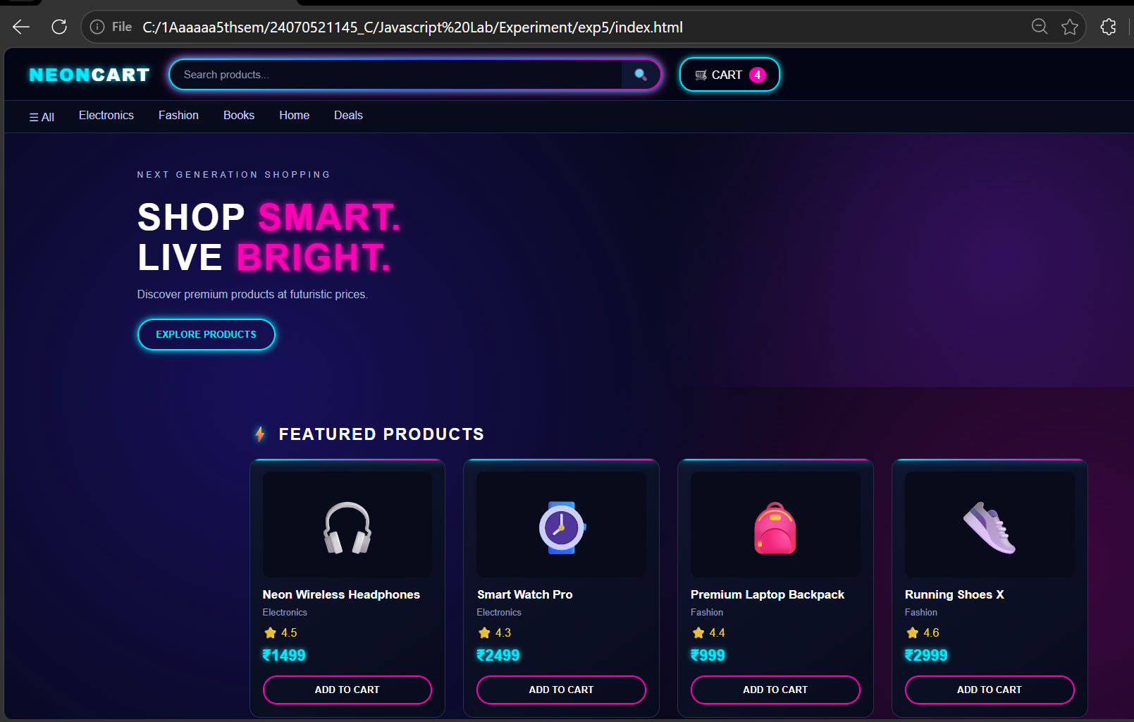
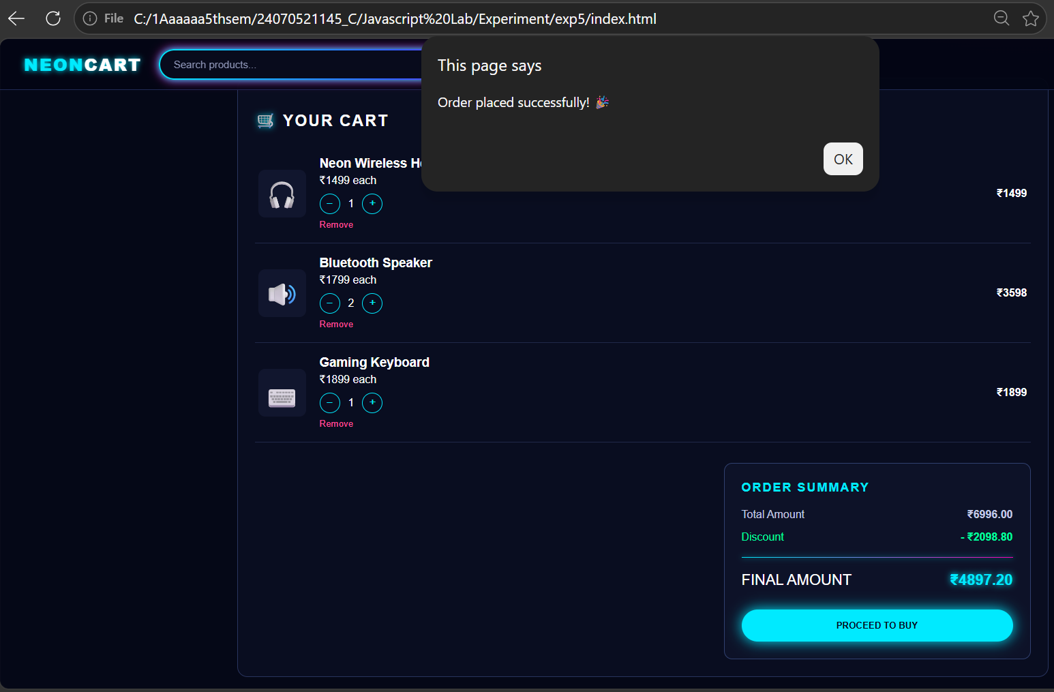
5.Result
The shopping cart application was successfully developed using HTML, CSS, and JavaScript. It provides an interactive e-commerce interface where users can browse products, search items, add or remove products, modify quantities, and view the cart summary. The application dynamically calculates the total amount, applicable discount, and final payable amount using JavaScript array methods and object handling.

